Crossroads Crisis Center, Inc.
Serving survivors of domestic violence since 1980
SHELTER EDUCATE EMPOWER ADVOCATE

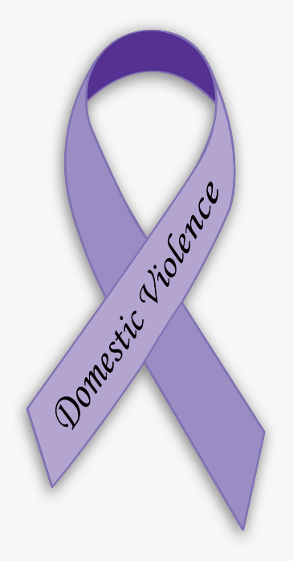

Annual Impact Report
2021

Mission
The mission of Crossroads Crisis Center is to enhance safety
for survivors of Domestic Violence and their children by educating,
advocating, and empowering individuals. Through our leadership and expertise, we strive to engage our communities in promoting no tolerance of Domestic Violence.

Vision Statement
We envision Crossroads Crisis Center to be a holistic victim
centered service agency wherein every victim, every time, is given respect,
compassion, dignity and individualized trauma-informed support wherein they can make informed choices to live self-sufficient, safer lives.

Crossroads’ Objective
To foster a supportive community of empowerment that
impacts victims of domestic violence to become safe and self-sufficient.

Value Statement
Do What’s Right
We are committed to the highest standards of ethics and integrity.
We believe honesty and integrity engender trust, which is the cornerstone of our
organization. We do not take ethical or professional shortcuts, and our interactions must
reflect the high standards that we profess. Our employees are valued and share
responsibility in fulfilling our mission.

Respect Others
We recognize that our success as an agency depends on the talent, skills and
expertise of our employees, as well as our collaborative partnerships and our ability to
function as an integrated team. We appreciate our diversity and believe that respect is an
essential element of all productive relationships. We want our organizational
structure and culture to promote employee involvement, open communication,
teamwork and cooperation. We believe that every person has a right to live
safe and free in their own homes and we respect the
self-determination of the clients we serve.

Commitment to Excellence
We understand the value of our mission and the trust that our clients place
in us. Guided by integrity and professionalism, we strive to help our clients achieve
their most challenging goals. We assume responsibility for our actions and hold ourselves
accountable to the clients we serve, their children and future generations, our employees,
our funders and our communities. We believe that by strengthening families, we are
making a stronger community for all. We believe that quality
service trumps quantity of services.

Guiding Principles
- We believe that all people have the right to live without fear of violence, abuse, or oppression.

- We believe that domestic violence serves as a functional and purposeful behavior that the batterer chooses in order to obtain and/or maintain power over the victim. That dominance is evidenced through a pattern of coercive control, and inclusive of physical, sexual, verbal/emotional, psychological and economic abuse.

- We promote safety, well-being and justice for all battered persons while respecting the adult survivors’ right to self-direction and control over their own lives. Crossroads’ programs are based on a trauma-informed voluntary service model. This philosophy acknowledges peoples’ competency and offers them support, resources, advocacy, information and education. We believe that survivors can break the cycle of domestic violence through supportive intervention because they possess the ability to make decisions that foster healthy, violence-free relationships.

- We affirm that batterers, not victims, are accountable for their abusive behaviors.

- We are committed to fostering changes necessary to eliminate personal, institutional and cultural oppression and violence. We believe that ending violence requires connection and collaboration with organizations and individuals, especially those who are/were battered, to create a clear vision and collective voice for social and systemic change.

- We are committed to advancing the communities’ responsibility for stopping the violence.

- Crossroads offers services to all victims of domestic violence regardless of race, color, ethnicity, age, gender, religious preference, disability status, sexual orientation, past or present involvement with substance abuse or mental illness, military or veteran status, or any other trait that is protected under local, state, or federal law.

Board of Trustees Serving in 2021
Ann Jenkins-President
Allen County Children Services

Vanessa Stallkamp-Vice President
Physician/OBGYN

Susan Odenweller-Treasurer
Chief Deputy Auditor, City of Lima

Molly Aregood-Secretary
Teacher/Admin. Assistant, Temple Christian School

Christine Graham
CASA Volunteer

Mildred Jackson-Retired
Risk Assessment Nurse, Agency on Aging

Kevin Martin
Chief of Police, City of Lima

Cherie Fairburn
911 Operator, State Highway Patrol

Andrew Heffner
Deputy Fire Chief, Lima Fire Department

Gayle Holdgreve-Retired
Trauma Services Data Coordinator, Mercy Health

Jodi Cartagena
Realtor/Agent, CCR

Adri Tucker
Head Teacher/Admin, CORS-Head Start

Sofia McDaniel
Law Student, ONU

Penny Parnell
Retired

Crossroads Crisis Center’s Staff

Christel Keller-12 years of experience
Executive Director – Registered Advocate/Senior Standing

Michelle Glasco-7 years of experience
Executive Assistant – Registered Advocate

Marcitta Sherrell-21 years of experience
Residential Service Coordinator – Registered Advocate/Senior Standing

Alexandria Bilikha->1 years of experience
Residential Service Advocate

Haley Walters-1 year of experience
Residential Advocate

Alexis Butler->1 years of experience
Residential Advocate

Leah Wilbert->1 years of experience
Residential Advocate

Sarah Binkley-15 years of experience
Court Advocacy Coordinator

Olivia DePalma-4 years of experience
Outreach Coordinator/Survivor Advocate-Registered Advocate

60 years of combined experience in domestic violence

Crossroads Service Programs

Education Program

Domestic Violence Support/Edu. Group
“Finding Purpose” (Residential & Offsite)
Cooking Class (Residential)
Self-Esteem Class
Financial Empowerment Sessions
Children’s Program (Residential)
Community Education
Social Media
Awareness Events
Domestic Violence Awareness Month Events
Silent Witness Initiative
Community Outreach

Residential Program

Emergency Confidential Shelter
Intensive Case Management
Individual and Housing Advocacy
On-Going Safety Planning
Financial Assistance (as funding allows)
Children’s Program
Life Skills
Transportation
Appropriate Information and Referrals
Follow-Up

24/7 Text/Chat Program- “Help Chat” (In addition to our 24/7 Crisis Hotline)

Support & Empowerment
Appropriate Information and Referrals
On-Going Safety Planning

Court Advocacy Program

Prosecution Advocacy and Accompaniment
Criminal Court Advocacy and Accompaniment
Civil Court Advocacy and Accompaniment
Notifications
CPO & TPO Accompaniment
Petition Assistance
Victims’ Rights Information and Referrals
Victims Impact Statement Assistance
Appropriate Information and Referrals
Transportation
On-Going Safety Planning

Mobile Advocacy/Non-Residential Program

Crisis Response
Intensive Case Management
Individual and Housing Advocacy
Transportation
Food Giveaway
Appropriate Information and Referrals
On-Going Safety Planning
Financial Assistance (as funding allows)

Crossroads is a partner agency of
- United Way of Greater Lima


Crossroads Crisis Center’s
The Allen County Community Domestic Violence Task Force is facilitated by:
Co-Chair-Olivia Depalma
Co-Chair-Sarah Binkley
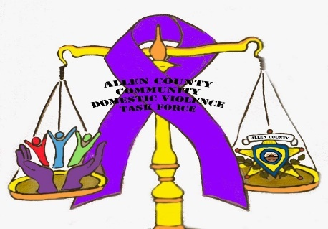

Crossroads is represented on the:
- Allen County Continuum of Care
- Allen County Family & Children First Council (FCFC)
- FCFC Steering Committee
- Allen County Healthy People 2030
- Allen County Housing Consortium
- Lima/Allen Elder Abuse Coalition – (I-Team)
- Ohio Domestic Violence Network (ODVN)
- ODVN Legal Caucus, Women of Color Caucus, and LGBTQ+ Caucus
- United Way of Greater Lima Council of Agencies
- Non-Congregate Sheltering
- Allen County Supportive Housing Project

Crossroads Collaboration Boards:
- VAWA – Prosecutor Meeting
- FVPSA – Allen County Community Domestic Violence Task Force

Crossroads service model:

Ohio Domestic Violence Network: Trauma Informed Care
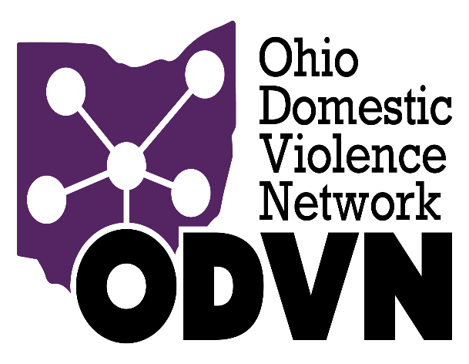

Crossroad’s funding sources:

Federal Funding – Victims of Crime Act (VOCA), Family Violence Prevention Services Act (FVPSA), Violence Against Women Act (VAWA),
Emergency Food and Shelter Program (EFSP)
State Funding – State Victims Assistance Act (SVAA), Family Violence Prevention Fund (FVP), DV Line Item in State Budget, DV Bonus HUD Funding
Local Funding – Marriage & Divorce fees, United Way of Greater Lima, Midwest Community Connection Funds, Community Donations

Crossroad’s In-kind Sources:

Volunteer/Intern – direct service hours.
Community Donations - clothing, household items, furniture, appliances, food, etc.
Donated space – (1) storage unit, a donated room for meetings at United Way of Greater Lima, and a donated office at The Lima Municipal Court for services provided to court clients.

Crossroads Crisis Center – Statistics 2021

Total Survivors/Clients Served | Allen County | Other County |  | Total
Women | 203 | 35 |  | 238
Men | 9 | 0 |  | 9
Children | 152 | 14 |  | 166
Anonymous Contacts | 829 | 0 |  | 829
Grand Total 1,193 49 |  |  |  | 1,242
Shelter Survivors/Clients | Allen County | Other County |  | Total
Women | 35 | 18 |  | 53
Men | 0 | 0 |  | 0
Children | 17 | 1 |  | 18
Grand Total 52 19 |  |  |  | 71
Court Survivors/Clients | Allen County | Other County |  | Total
Women | 89 | 14 |  | 103
Men | 6 | 0 |  | 6
Children | 119 | 11 |  | 130
Grand Total 214 25 |  |  |  | 239
Non-Residential Survivors/Clients | Allen County | Other County |  | Total
Women | 79 | 3 |  | 82
Men | 3 | 0 |  | 3
Children | 16 | 2 |  | 18
Grand Total 98 5 |  |  |  | 103
Other- Statistics 2021
Units of Services Provided |  |  |  | 110930.75
Survivor Related/Crisis Line Calls |  |  |  | 1844
Referrals Made |  |  |  | 1259
Meals Provided |  |  |  | 7,926
Food Boxes Prepared |  |  |  | 15
Support Groups Facilitated |  |  |  | 54
Provided Christmas |  | Adults 13 |  | Children 7
Intern/Volunteer Hours |  |  |  | 638
Value of In-Kind Donations |  |  |  | $161,355.14
Service Hours Provided |  |  |  | 178,267.25
Chat/Text Messages |  |  | 108 Incoming | 93 Outgoing
Temporary Protection Order (TPO) |  |  | 7 Requested | 3 Obtained
Civil Protection Order (CPO) |  |  | 6 Requested | 10 Obtained
Court Notifications Completed |  |  |  | 588
Hearings Attended (with or without survivor) |  |  |  | 642
Shelter Days Provided |  |  | 1940 Individual | 2837 Family
Average Shelter Days |  |  | 37 Days
Surveys Received |  |  |  | 95
Community Presentations |  |  | 24 Presentations | 318 Participants
Awareness Events |  |  |  | 15

Comments from Survivors:
Residential Program:
- I feel I got an outstanding chance! I had a great time with staff!
- I love the whole staff, very kind hearted people.
- The kindness of the staff when I needed it most.
- As I learned about the REACH program, I felt so much hope for my future! I am now getting my own place thanks to their help and determination in helping me progress. I am very thankful.

Court Advocacy Program:
- They helped me understand all about the court process.
- I felt safe when I came to court.
- Always available & helpful when I would call the crisis line, compassion & listening ear.
- The staff are very helpful and supportive.

