
Crossroads Crisis Center, Inc.
Serving survivors of domestic violence since 1980
SHELTER EDUCATE EMPOWER ADVOCATE

Annual Report
2022

Mission
The mission of Crossroads Crisis Center is to enhance safety
for survivors of Domestic Violence and their children by educating,
advocating, and empowering individuals. Through our leadership and expertise, we strive to engage our communities in promoting no tolerance of Domestic Violence.

We are dedicated to our mission and serving all survivors of domestic violence, dating violence, intimate partner violence, family violence, sexual violence, and human trafficking

Vision Statement
We envision Crossroads Crisis Center to be a holistic victim
centered service agency wherein every victim, every time, is given respect,
compassion, dignity and individualized trauma-informed support wherein they can make informed choices to live self-sufficient, safer lives.

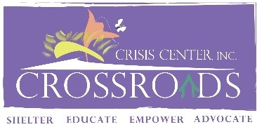

Ann Jenkins-President
Our Team
Christel Keller
Executive Director – Registered Advocate/Senior Standing

Michelle Glasco
Executive Assistant – Registered Advocate

Marcitta Sherrell
Residential Service Coordinator – Registered Advocate/Senior Standing

Mary Smicklas
Housing Advocate

Alysha Mesojednik
Residential Advocate

Elizabeth Bower
Residential Advocate

Meranda McDowell
Residential Advocate

Alexis Butler
Court Advocacy Coordinator

Alexandria Bilikha
Court Advocate

Kathryn Hunter
Court Advocate

Olivia DePalma
Outreach Coordinator/Survivor Advocate-Registered Advocate

50 years of combined experience in domestic violence

Board of Directors

Allen County Children Services

Vanessa Stallkamp-Vice President
Physician/OBGYN

Susan Odenweller-Treasurer
Chief Deputy Auditor, City of Lima

Molly Aregood-Secretary
Teacher/Admin. Assistant, Temple Christian School

Christine Graham
CASA Volunteer

Mildred Jackson-Retired
Risk Assessment Nurse, Agency on Aging

Andrew Heffner
Lima Fire Chief, Lima Fire Department

Gayle Holdgreve-Retired
Trauma Services Data Coordinator, Mercy Health

Jodi Cartagena
Realtor/Agent, CCR

Adri Tucker

Head Teacher/Admin, CORS-Head Start

Joseph Snyder

Prosecutor, City of Lima

P.O. Box 643
Lima, Ohio 45802
Fax: 419-228-5431
Website: www.crossroadscrisiscenter.com
email: crossroadscrisis@gmail.com

24/7 Crisis Hotline
419-228-HELP (4357)
24/7 Text & Chat
419-228-4357 or www.crossroadscrisiscenter.com

Programs & Services


Education Program

Domestic Violence Support/Edu. Group
“Finding Purpose” (Residential & Offsite)
Cooking Class (Residential)
Self-Esteem Class
Financial Empowerment Sessions
Children’s Program (Residential)
Community Education
Social Media
Awareness Events
Domestic Violence Awareness Month Events
Silent Witness Initiative
Community Outreach


Residential Program

Emergency Confidential Shelter
Intensive Case Management
Housing Advocacy
On-Going Safety Planning
Financial Assistance (as funding allows)
Children’s Program
Life Skills
Transportation
Appropriate Information and Referrals
Follow-Up

24/7 Text/Chat Program- “Help Chat” (In addition to our 24/7 Crisis Hotline)

Support & Empowerment
Appropriate Information and
Referrals
On-Going Safety Planning



Court Advocacy Program

Prosecution Advocacy and Accompaniment
Criminal Court Advocacy and Accompaniment
Civil Court Advocacy and Accompaniment
Notifications
CPO & TPO Accompaniment

Petition Assistance
Victims’ Rights Information and Referrals
Victims Impact Statement Assistance
Appropriate Information and Referrals
Transportation
On-Going Safety Planning

Mobile Advocacy/Non-Residential Program
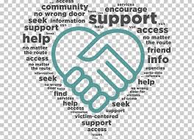
Crisis Response

Intensive Case Management
Housing Advocacy

Transportation
Food Giveaway
Appropriate Information and Referrals
On-Going Safety Planning
Financial Assistance (as funding allows)

Crossroads Crisis Center’s
The Allen County Community Domestic Violence Task Force is facilitated by:
Chair-Alexis Butler
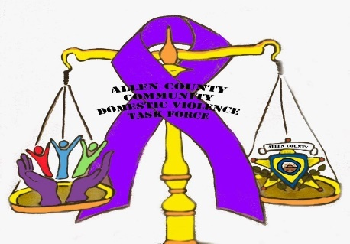

Crossroads is represented on the:
- Allen County Continuum of Care
- Allen County Family & Children First Council (FCFC)
- Lima/Allen Elder Abuse Coalition – (I-Team)
- Ohio Domestic Violence Network (ODVN)
- ODVN Legal Check-in, Women of Color Caucus, and LGBTQ+ Caucus
- United Way of Greater Lima Council of Agencies
- Allen County Homeless Solutions

Crossroads Collaboration Boards:
- VAWA – Prosecutor Meeting
- FVPSA – Allen County Community Domestic Violence Task Force

Crossroads service model:
Ohio Domestic Violence Network: Trauma Informed Care
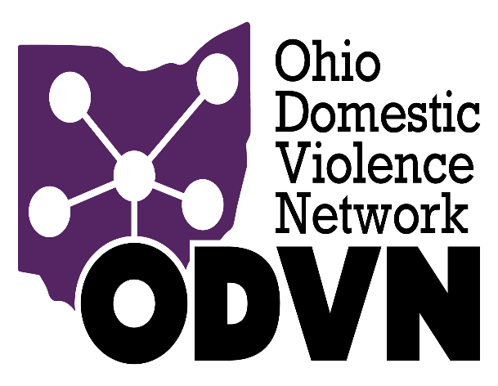
Financials Statements 2020/2021
Income

Our programs are funding in part by local, state, and federal dollars:
Federal:
Victim of Crime Act (VOCA)
Family Violence Prevention Service Act (FVPSA)
Violence Against Women Act (VAWA)
Emergency Food and Shelter Program (EFSP)
Family Violence Prevention Service Act 2021
American Rescue Plan Supplemental Funding
(FVPSA-ARP)

State:
State Victim Assistance Act (SVAA)
Family Violence Prevention Funds (FVP)
DV Line Item in State Budget
Fresh Start HUD Funding

Local:
Marriage & Divorce Fees
United Way of Greater Lima
Midwest Community Connection Funds
Community Donations
City of Lima (Court Program)
Mercy Health
Mental Health Recovery Services Board

Expenses

Crossroad’s In-kind Sources

Volunteer/Intern:
Direct service hours

Community Donations:
Clothing
Household items
Furniture
Appliances
Food

Donated space:
Storage unit
Room for meetings at United Way of Greater
Lima
Office at The Lima Municipal Court for
services provided to court clients

Crossroads Crisis Center is a 501(C)3 Organization

Crossroads Crisis Center – Statistics 2022

Total Survivors/Clients Served | Allen County | Other County | Total
Women | 408 | 38 | 446
Men | 58 | 1 | 59
Children | 205 | 16 | 221
Anonymous Contacts | 1,056 | 0 | 1,056
Grand Total 1,727 55 |  |  | 1,782
Shelter Survivors/Clients | Allen County | Other County | Total
Women | 46 | 21 | 67
Men | 0 | 1 | 1
Children | 19 | 16 | 35
Grand Total 65 38 |  |  | 103
Court Survivors/Clients | Allen County | Other County | Total
Women | 239 | 2 | 241
Men | 49 | 0 | 49
Children | 141 | 0 | 141
Grand Total 429 2 |  |  | 431
Non-Residential Survivors/Clients | Allen County | Other County | Total
Women | 123 | 15 | 138
Men | 9 | 0 | 9
Children | 45 | 0 | 45
Grand Total 177 15 |  |  | 192
Programs and Services

Emergency Shelter & Advocacy
Crossroads provided 3,076 shelter bed nights with an average of 16 days
Advocates answered 1,802 crisis hotline calls
1,193 meals were provided to survivors and their children

Court Advocacy
431 survivors were assisted with civil and criminal court accompaniment
Court advocates provided civil advocacy assistance and accompaniment to 13 survivors for civil protection orders
736 court hearings were attended by court advocates with or on behalf of survivors
Court advocates provided 509 court notifications to survivors about their upcoming court proceeding

Non-Residential/Mobile Advocacy
192 survivors received mobile advocacy services such as safety plans, financial assistance, housing advocacy and were connected to community resources
21 food boxes were prepared for survivors

Education
31 Finding Purpose educational support groups was facilitated
4 survivors received a certificate of completion
18 Financial Empowerment session was facilitated

Help Chat
Advocates responded to 287 text & chats
20 information and referrals were provided via text and/or chat

Community and Volunteers
26 volunteers provide 724.25 hours of services in our emergency shelter and in the court program
Engaged over 200 community members in domestic violence education
5 domestic violence awareness events were hosted by Crossroads in October for Domestic Violence Awareness Month
Crossroads collected $175,965 of in-kind community donations
My advocate was very understanding and she listen to what I had to say and she tried to help me in every way. She was very pleasant
-Survivor

This program saved my life. I decided to become a survivor. I felt the world against me but then I found Crossroads. They were there for me, they assisted me in becoming a strong individual and learning to once again love myself. I will always be a supporter of this program
-Survivor
Staff is amazing, with the support I get from friends and family, I definitely feel respected and cared for. Since I’ve been here, I’ve cared for my future & my kids more!
-Survivor

