Annual Report
2023

Crossroads Crisis Center, Inc.

Educate Advocate Empower
Mission
The mission of Crossroads Crisis Center is to enhance safety
for survivors of Domestic Violence and their children by educating,
advocating, and empowering individuals. Through our leadership and expertise, we strive to engage our communities in promoting no tolerance of Domestic Violence.

Our Team

Christel Keller
Executive Director – Registered Advocate/Senior Standing

Michelle Glasco
Executive Assistant – Registered Advocate/Senior Standing

Marcitta Sherrell
Resident Advocate
Registered Advocate/Senior Standing

Mary Smicklas
Housing Advocate-Registered Advocate

Alysha Mesojednik
Residential Service Coordinator

Alexis Butler
Court Advocacy Coordinator-Registered Advocate

Alexandria Bilikha
Court Advocate-Registered Advocate

Kathryn Hunter
Court Advocate-Registered Advocate

Olivia DePalma
Outreach Coordinator/Survivor Advocate-Registered Advocate

Morgan Snyder
Resident Advocate

Ashely Morales
Resident Advocate

Hannah Hassan
Resident Advocate

Ann Jenkins-President

Board of Directors

Vanessa Stallkamp-Vice President
Susan Odenweller-Treasurer
Molly Aregood-Secretary
Christine Graham
Mildred Jackson
Andrew Heffner
Gayle Holdgreve

Jodi Cartagena
Adri Tucker

Joseph Snyder

Ann Stiles

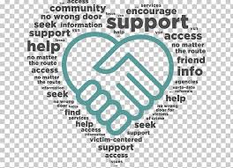

Crossroads Crisis Center

2023 Non-Profit of the Year

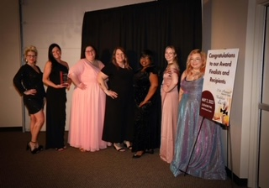

Sponsored by:

The Lima Allen County Chamber of Commerce and Cenovus Lima Refinery

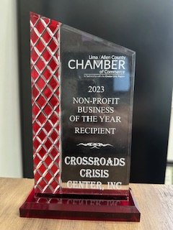

Programs & Services


Education Program

Domestic Violence Support/Edu. Group
“Finding Purpose” (Residential & Offsite)
Cooking Class (Residential)
Self-Esteem Class
Financial Empowerment Sessions
Children’s Program (Residential)
Community Education
Social Media
Awareness Events
Domestic Violence Awareness Month Events
Silent Witness Initiative
Community Outreach


Residential Program

Emergency Confidential Shelter
Intensive Case Management
Housing Advocacy
On-Going Safety Planning
Financial Assistance (as funding allows)
Children’s Program
Life Skills
Transportation
Appropriate Information and Referrals
Follow-Up

24/7 Text/Chat Program- “Help Chat” (In addition to our 24/7 Crisis Hotline)

Support & Empowerment
Appropriate Information and
Referrals
On-Going Safety Planning



Court Advocacy Program

Prosecution Advocacy and Accompaniment
Criminal Court Advocacy and Accompaniment
Civil Court Advocacy and Accompaniment
Notifications
CPO & TPO Accompaniment

Petition Assistance
Victims’ Rights Information and Referrals
Victims Impact Statement Assistance
Appropriate Information and Referrals
Transportation
On-Going Safety Planning

Mobile Advocacy/Non-Residential Program
Crisis Response

Intensive Case Management
Housing Advocacy

Transportation
Food Giveaway
Appropriate Information and Referrals
On-Going Safety Planning
Financial Assistance (as funding allows)
Follow-up

Financials Statements 2022/2021
Income

Our programs are funding in part by local, state, and federal dollars:
Federal:
Victim of Crime Act (VOCA)
Family Violence Prevention Service Act (FVPSA)
Violence Against Women Act (VAWA)
Emergency Food and Shelter Program (EFSP)
Family Violence Prevention Service Act
American Rescue Plan Supplemental Funding
(FVPSA-ARP)

State:
State Victim Assistance Act (SVAA)
Family Violence Prevention Funds (FVP)
DV Line Item in State Budget

Local:
Marriage & Divorce Fees
United Way of Greater Lima
Midwest Community Connection Funds
Community Donations
Mercy Health
Mental Health Recovery Services Board

Expenses

Crossroad’s In-kind Sources

Volunteer/Intern:
Direct service hours

Community Donations:
Clothing
Household items
Furniture
Appliances
Food

Donated space:
Storage unit
Room for meetings at United Way of Greater
Lima
Office at The Lima Municipal Court for
services provided to court clients

Crossroads Crisis Center is a 501(C)3 Organization

Our Impact

Court Advocacy
Residential Program

3,571 shelter bed nights were provided to 121 survivors and their children
Advocates answered 2,197 crisis hotline calls
10,713 meals provided
472 Survivors assisted with civil/criminal court accompaniment
13 Survivors received civil advocacy for CPO’s
757 court hearings attended with or on behalf of a survivor

Education Program
Mobile Advocacy/Non-Residential Program

153 Adults received prevention programming
33 Finding Purpose educational support groups facilitated
38 Financial Empowerment Sessions Facilitated

148 survivors received supportive services such as safety planning, financial assistance and housing advocacy.
12 RING cameras were provided to survivors to enhance their safety

24/7 Text/Chat Program-Help Chat

Statistics-2023
Residential Program
Adults | 72
Children | 49

Court Advocacy Program
Adults | 316
Children | 156

Mobile Advocacy/Non-Residential Program
Adults | 96
Children | 52

Anonymous Contacts
Adults | 1,187

Advocates responded to 312 text and chats
Information and referrals were provided 31 times via text/chat

Crossroads service model:
Ohio Domestic Violence Network: Trauma Informed Care
